Separating Fact from Fiction
Darwin Kastle
After playing with Invasion in Constructed for a while, I decided that an important new Magic skill was going to be making good piles when my opponents cast Fact or Fiction. Fact or Fiction sees lots of play in Standard, some play in Extended, and it's even good in Classic. It will see lots of play in Block, and it may be the best blue card in draft. I think the ease with which someone can make the piles poorly makes the card even more powerful. The card is so powerful that there is now a commonly used acronym referring to it: EOTFOFYL. End of Turn Fact or Fiction You Lose!
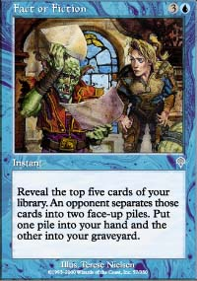
Most people I know dislike the card because they are never sure how to make the piles well. It may just be overconfidence, but I think I'm starting to get the hang of it. I feel like I've won multiple games by making piles that tempted my opponent into not taking the pile with the card that I was most worried about. I find the fact that I've played lots of Solomon Draft and gotten good at that process to be quite helpful.
Don't get me wrong, the card is so good sometimes it doesn't matter how you make the piles. This card is so good that it's good even when it's bad. Turn over five lands? Good thing that's not your next five draw steps. No matter what, the idea is to make it hard on your opponent to make the right choice.
There are three main factors to consider: the five cards that have been turned over, the board/life situation, and the cards in your hand. Also, take note of how many cards your opponent has and the mana he/she has to work with. If you're lucky, you will have your opponent under heavy pressure, they will be having mana problems, and/or the five cards will suck.
Let's start with what the five cards are. Some sets are relatively easy: five land, one very good card and four bad cards, two important cards and three meaningless cards. It's when there are three or more meaningful cards that it starts to get really difficult. The board/life situation and what you have in your hand are the main ways to decide which cards are meaningful.
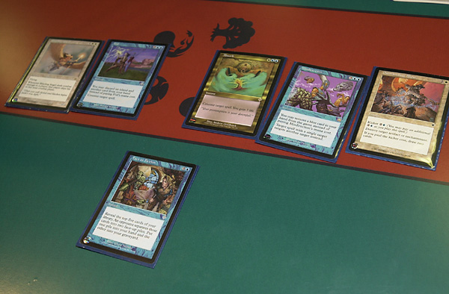
If you are already losing, Fact or Fiction often means doom for you. If the game is close or if you are winning, then the importance of making the right piles becomes magnified. The better your position, the fewer cards will be meaningful.
Much like Solomon Draft, there are two main methods: make the piles as close to identical as possible, or try to fool your opponent. The first method is easier and safer. When you're not sure what to do, it is probably the way to go. The second method is harder and riskier, but the potential rewards are greater.
The key to fooling your opponent is to convince them that your hand gives you important information that they don't have. One approach is to make the piles quickly and confidently. Put a normally powerful card that because of your hand you're not afraid of (I will call this the decoy) in a pile with something of little importance, maybe an excess land. Then the other pile will be composed of the three remaining cards, including the card you're actually most afraid of. Hopefully your opponent will become convinced that the decoy in the smaller pile scares the living daylights out of you and take it. I don't recommend overdoing this. Try to balance the piles enough that if your strategy backfires you might still have a chance to win. Of course if you're desperate enough you can take whatever risks you think necessary.
Some people pretend to agonize over making two even piles and then suddenly put the decoy card in a pile by itself, shaking their head and saying, "those are the piles!" One of the risks of this strategy is that this closely resembles what many lesser players sometimes do, which is to think a long time and then suddenly give up and make a very poor separation. Many players will assume this is what has happened and not take the decoy pile, sometimes even mocking your ineptitude. It can sometimes help to mutter something like, "why did you have to turn over this card," right before putting the decoy by itself. This strategy is also risky if you're not a good actor, because a poorly delivered "line" can reveal your ploy. The hope is that your opponent won't believe you are brazen enough to put a meaningless card by itself.
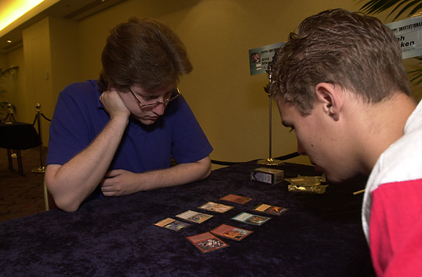
Fact or Fictioning is like playing Solomon Draft
A Fact or Fiction immediately when your opponent reaches four mana can be quite interesting, especially if they didn't arrive at four mana promptly. In this situation I like to put all the land in one pile and the spells in the other. Now you are often guaranteeing a reasonable outcome. Either he is able to have some land to go with the spells he already had, or now he has some extra spells but often without enough mana to exploit this. Its important to separate the cards your opponent wants from those they need. While you should try not to be too greedy when making the separation, you should try and punish your opponent for being greedy. For example, when there is another Fact or Fiction among the five cards I'm separating, I often like to put it with the decoy pile. The other pile sometimes contains something so scary that I want to take my chances and another entire turn of my opponent's on a new Fact or Fiction. This is a trap many opponents fall for, since they are playing with Fact or Fiction they are usually a big fan of casting them whenever possible. As powerful as cards like Fact or Fiction are, it's usually dangerous to take too many turns for searching and card drawing and not actually doing anything that affects the board.
I recently found out one of the other limitations of Fact or Fiction. One of the most popular Standard decks using Fact or Fiction is blue/white control. In the past, especially in Classic, card advantage was the key to control versus control. These Standard decks have only six or seven creatures and yet they contain four Wrath of Gods and twelve or more permission spells. At Pro Tour-Chicago, Justin Gary discovered much to his surprise that the key to this mirror match was to not counter or cast Fact or Fiction. With the low number of threats in these decks and the high number of answers, decking became the primary path to victory. Fact or Fiction became a way to ensure that you were the one being decked. This is probably the only match-up where the casting of Fact or Fiction should be viewed with pleasure instead of dread.
Practicing your pile making can help. I practice by taking test draws of decks with Fact or Fiction and then trying to figure out what piles would present me with the toughest choice. You know you've separated well when they take a long time deciding which pile to take and especially if they take a one-card pile. Just remember they had to waste a turn casting Fact or Fiction and they will need the extra card or cards they gain to make up for the time they lost getting them. Don't lose heart and make those piles with care and confidence. This is a skill you will need for quite some time, so don't ignore it. Good luck.

